SCHOOL OF COMPUTER SCIENCE AND ARTIFICIAL INTELLIGENCE |  |  |  |  | DEPARTMENT OF COMPUTER SCIENCE ENGINEERING
Program Name: B. Tech |  |  |  | Assignment Type: Lab |  |  | Academic Year:2025-2026
Course Coordinator Name |  |  |  | Venkataramana Veeramsetty
Instructor(s) Name |  |  |  | Dr. V. Venkataramana (Co-ordinator)  Dr. T. Sampath Kumar  Dr. Pramoda Patro  Dr. Brij Kishor Tiwari  Dr.J.Ravichander  Dr. Mohammand Ali Shaik  Dr. Anirodh Kumar  Mr. S.Naresh Kumar  Dr. RAJESH VELPULA  Mr. Kundhan Kumar  Ms. Ch.Rajitha  Mr. M Prakash  Mr. B.Raju  Intern 1 (Dharma teja)  Intern 2 (Sai Prasad)  Intern 3 (Sowmya)  NS_2 ( Mounika)
Course Code |  |  | 24CS002PC215 | Course Title |  | AI Assisted Coding
Year/Sem |  |  | II/I | Regulation |  | R24
Date and Day  of Assignment |  |  | Week6 - Monday | Time(s)
Duration |  |  | 2 Hours | Applicable to  Batches
AssignmentNumber:12.1(Present assignment number)/24(Total number of assignments)
 | Q.No. | Question |  |  |  |  |  | Expected Time  to complete
 | 1 | Lab 12: Algorithms with AI Assistance – Sorting, Searching, and Optimizing Algorithms  Lab Objectives:  - Apply AI-assisted programming to implement and optimize sorting and searching algorithms.  - Compare different algorithms in terms of efficiency and use cases.  - Understand how AI tools can suggest optimized code and complexity improvements.  Task Description #1 (Sorting – Merge Sort Implementation)  - Task: Use AI to generate a Python program that implements the Merge Sort algorithm.  - Instructions:  - Prompt AI to create a function merge_sort(arr) that sorts a list in ascending order.  - Ask AI to include time complexity and space complexity in the function docstring.  - Verify the generated code with test cases.  - Expected Output:  - A functional Python script implementing Merge Sort with proper documentation.  Prompt (1.1) : write a python program which implements merge sort algorithm by creating a function and taking user input and sorts the list in ascending order.  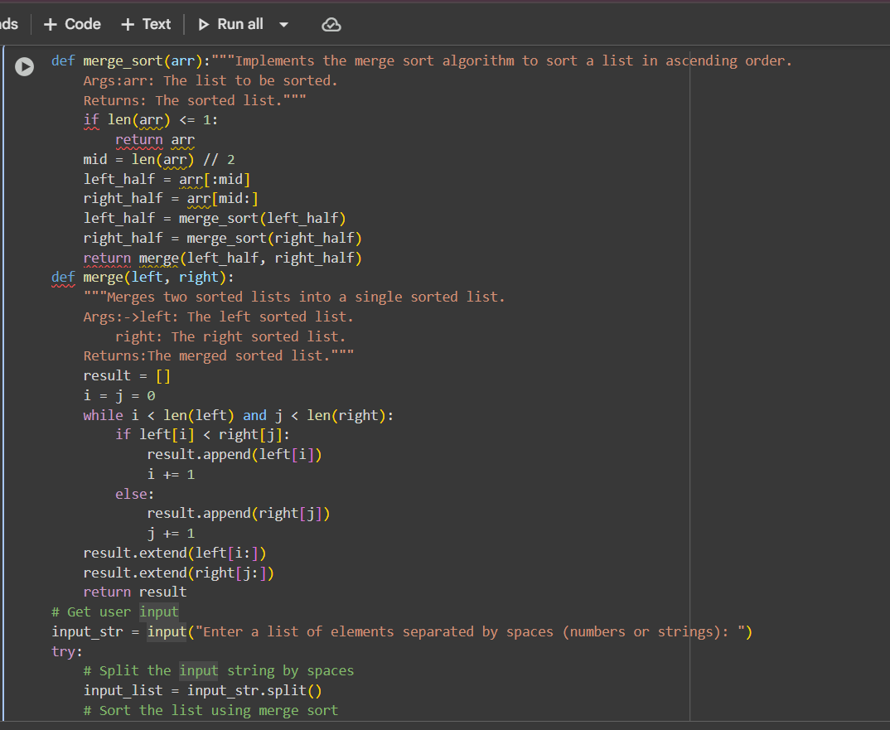  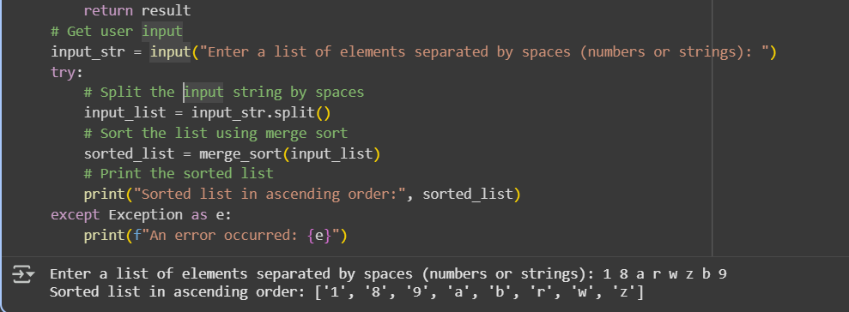  Prompt (1.2) : Write a python program which includes time complexity and space complexity by using doc string function.  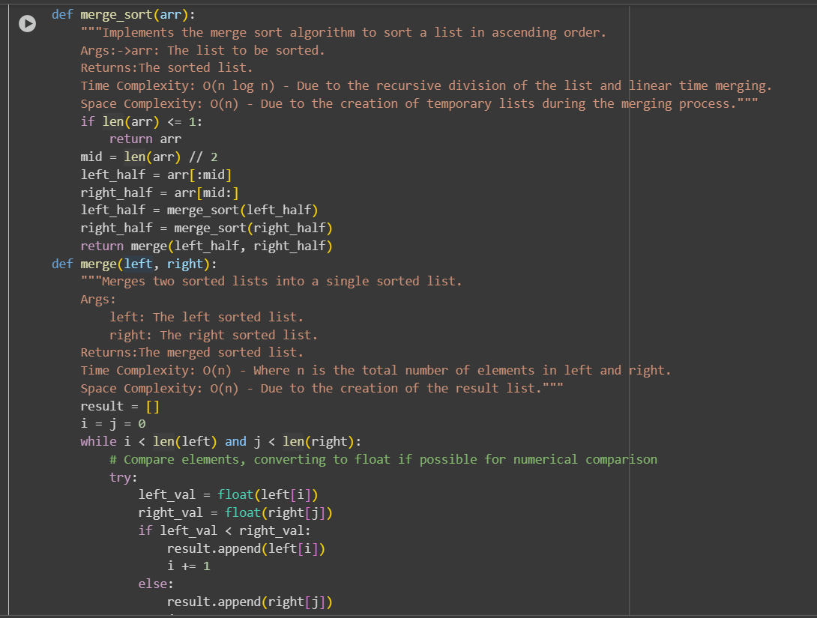  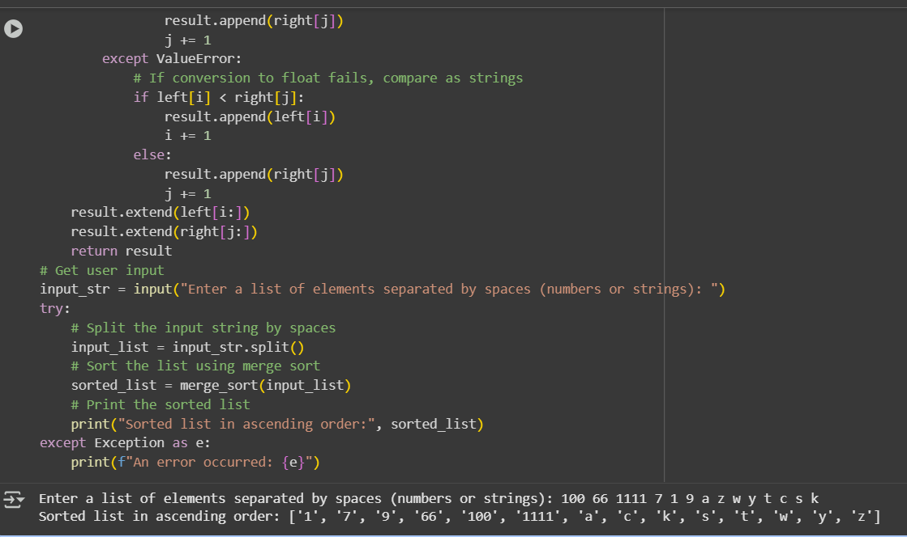  Prompt (1.3) : Now generate test cases for this code (any 2 simple ones)  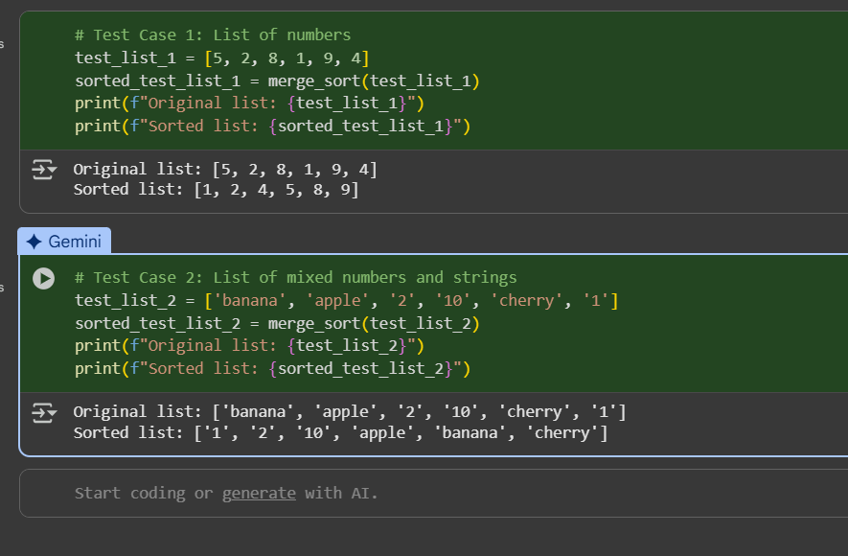  Task Description #2 (Searching – Binary Search with AI Optimization)  - Task: Use AI to create a binary search function that finds a target element in a sorted list.  - Instructions:  - Prompt AI to create a function binary search (arr, target) returning the index of the target or -1 if not found.  - Include docstrings explaining best, average, and worst-case complexities.  - Test with various inputs.  - Expected Output:  - Python code implementing binary search with AI-generated comments and docstrings.  Prompt (2.1) : Write a python programme to create a function for binary search (arr , target ) returning index of target or -1 if not found .(take input from user and generate output) .  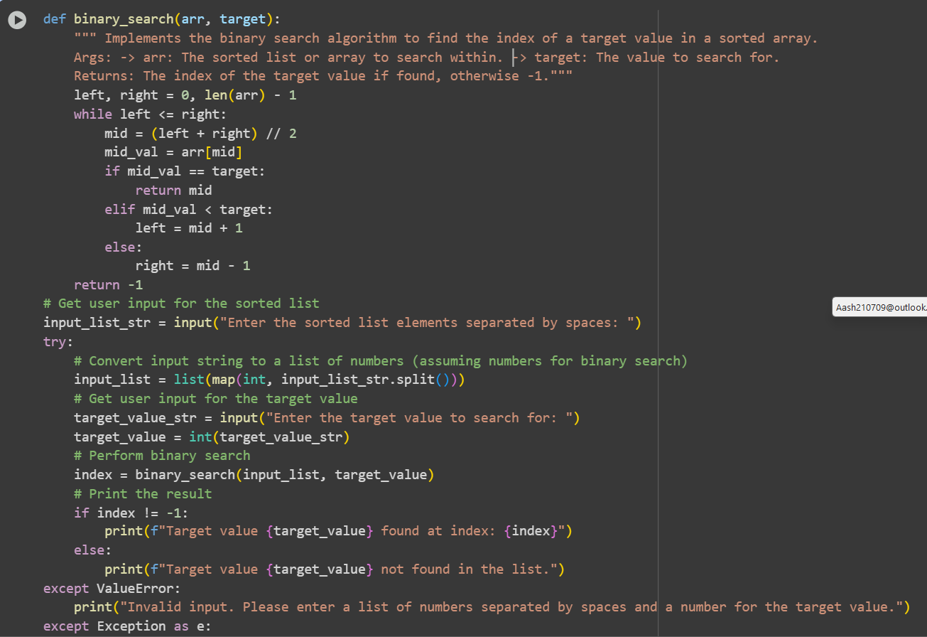  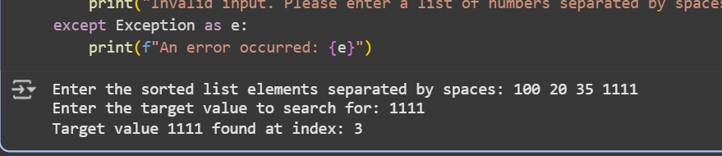  Prompt (2.2) : now include docstrings which should explain best , average and worst-case complexities  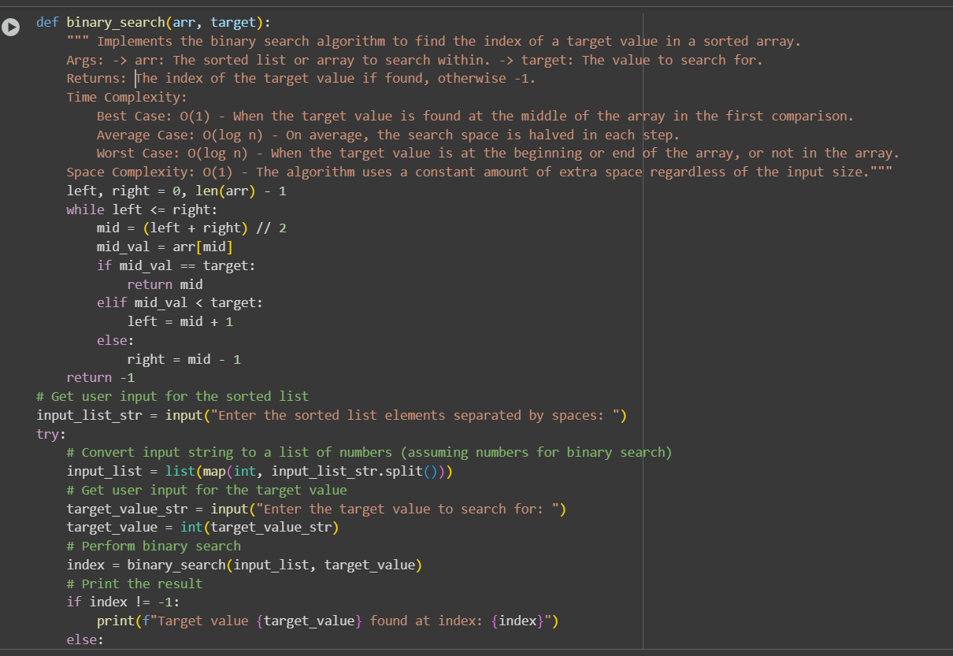  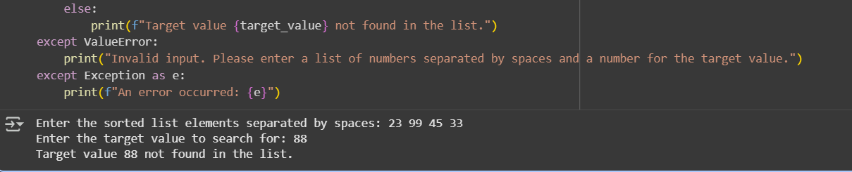  Prompt (2.3) : Now test with various inputs.  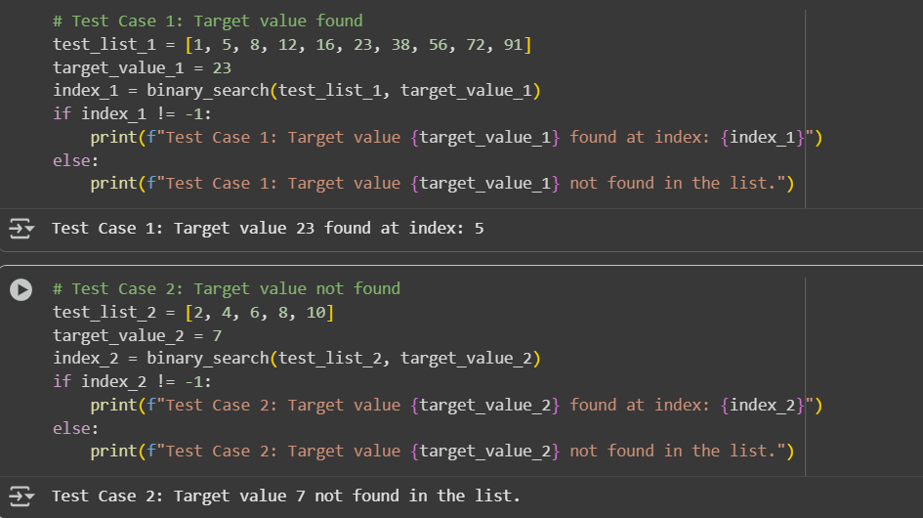  Task Description #3 (Real-Time Application – Inventory Management System)  - Scenario : A retail store’s inventory system contains thousands of products, each with attributes like product ID, name, price, and stock quantity. Store staff need to :  - Quickly search for a product by ID or name.  - Sort products by price or quantity for stock analysis.  - Task :  - Use AI to suggest the most efficient search and sort algorithms for this use case.  - Implement the recommended algorithms in Python.  - Justify the choice based on dataset size, update frequency, and performance requirements.  - Expected Output:  - A table mapping operation → recommended algorithm → justification.  - Working Python functions for searching and sorting the inventory.  Prompt (3.1) : Write a python program for effecient search and sort the algorithms for the retail store inventor system which contains thousands pf products , each with attributes like product Id, name , price and stock quantity.  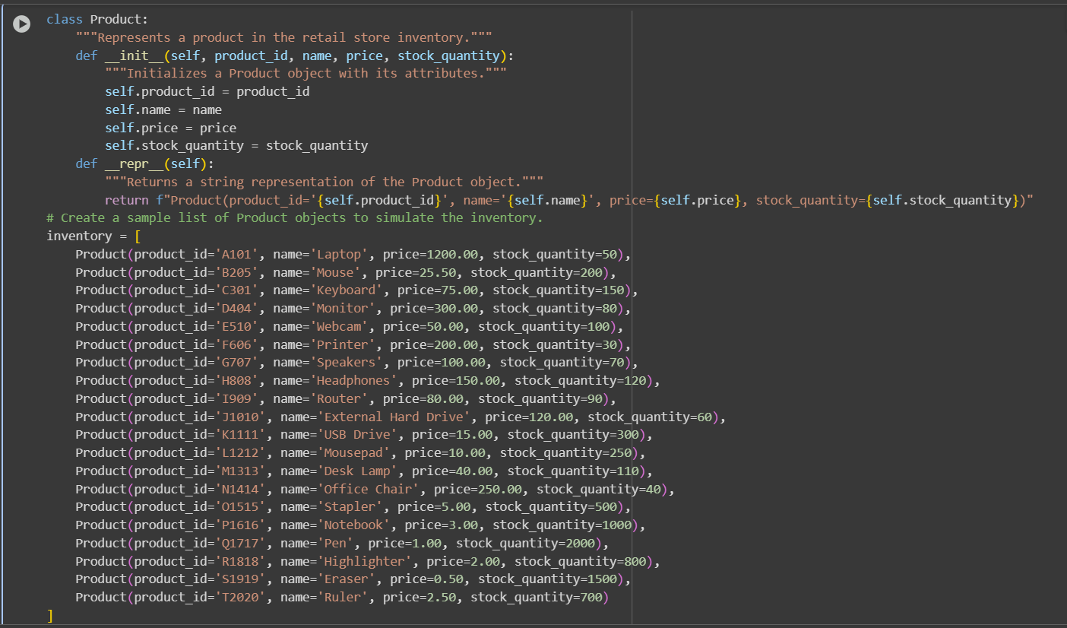  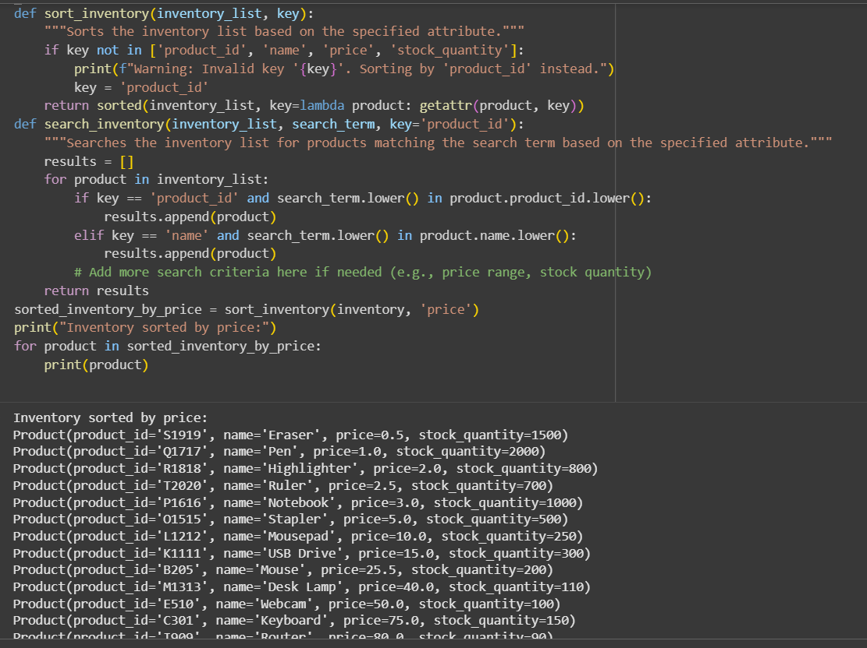  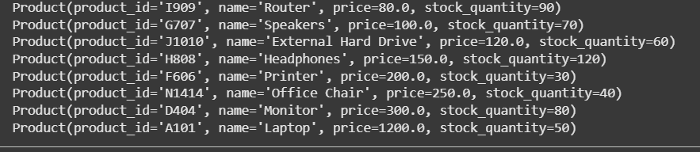  Prompt (3.2) : give me alogorithm in python code  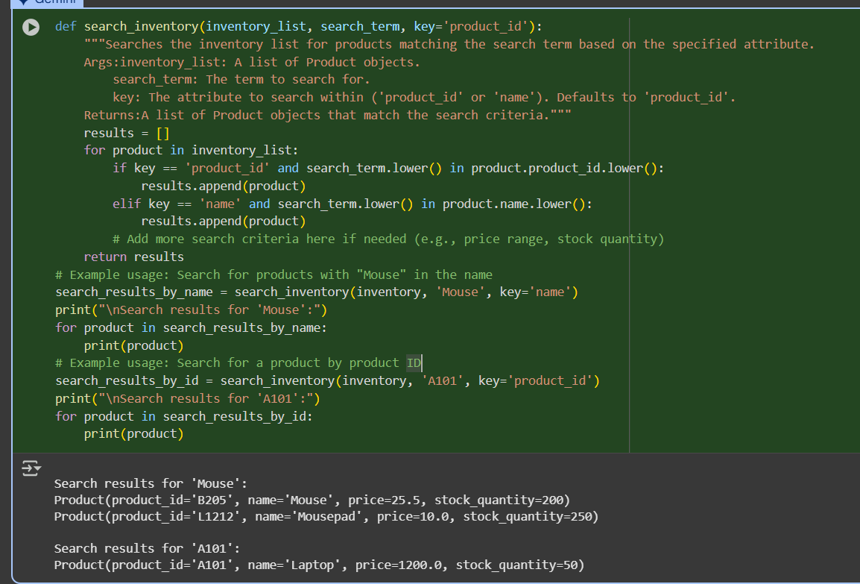  (3.3) Justification :  The current code uses a small sample dataset for demonstration purposes. In a real-world retail inventory system with thousands of products, the dataset size would be significantly larger.  Regarding update frequency, the inventory would need to be updated frequently to reflect sales, new stock arrivals, and returns. The current code does not include functionality for updating the inventory, but this would be a crucial aspect of a complete system.  For performance, the current search implementation is a linear search, which can become slow for large datasets. For a system handling thousands of products, a more efficient search algorithm, such as a binary search (if the data is sorted by the search key) or using a hash map/dictionary for O(1) average time complexity lookups by product ID, would be necessary to meet performance requirements. Similarly, while the built-in sorted() function is efficient (Timsort), for very frequent sorting of extremely large datasets, evaluating the performance of other sorting algorithms like merge sort or quicksort in the specific environment might be beneficial.  Deliverables (For All Tasks)  - AI-generated prompts for code and test case generation.  - At least 3 assert test cases for each task.  - AI-generated initial code and execution screenshots.  - Analysis of whether code passes all tests.  - Improved final version with inline comments and explanation.  - Compiled report (Word/PDF) with prompts, test cases, assertions, code, and output. |  |  |  |  |  | Week6 - Monday

